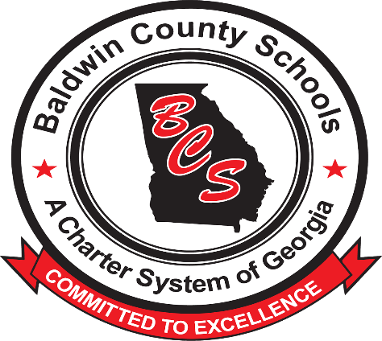
BALDWIN COUNTY SCHOOLS
“A CHARTER SYSTEM OF GEORGIA”

PURSUIT OF EXCELLENCE AWARDS PROGRAM

Nomination Form

Nominations are due the 1st Tuesday of the month (employees will be recognized the following month). Forms may be emailed to JudiBattle@baldwin.k12.ga.us or sent to the Baldwin County Board of Education-Human Resources Department located at 110 N. ABC Street, Milledgeville, Georgia 31061

- Nominee: ___________________________________________________________________
In the space below, briefly explain why you feel this person should receive a Pursuit of Excellence Award. One additional double-spaced page may be attached, if needed.
- ______________________________________________________________________________________________________________________________________________________________________________________________________________________________________________________________________________________________________________________________________________________________________________________________________________________________________________________________________________________________________________________________________________________________________________________________________________________________________________________________________________________________
Nominator’s Signature: ___________________________________________________________________
Print Name: __________________________Relationship to nominee: __________
Nominator’s email address and phone number: ___________________________________________________________________

