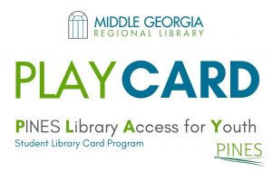

The Baldwin County Schools is partnering with the Georgia PINES Library Network to provide our students access to The PINES Library Card Access for Youth (PLAY) program. This program will give our students free access to public library materials and online resources to help them succeed in school. Students in Baldwin County can use their lunch number to access their PLAY Card account just like they would use a library card. The PLAY Card is free and will give our students access to public library resources and services. There are no overdue fines for materials checked out through a student’s PLAY Card. Fees apply only for lost or damaged materials. Students that already have a library card may use both the PLAY account and their original library card. The PLAY account will be an entirely separate account.The public library provides free access to books and online resources to help our students succeed in school, as well as fun resources that help develop a lifelong love of reading. Our public library is available all year long, with access to computers and laptops available for checkout, internet access, research assistance, teen leadership programs, and volunteer activities.

If you would like your child to participate, you do not need to do anything. We will share your information with the Pines Library System, and your child will have access to the Georgia PINES Network which includes 300 libraries in Georgia and will allow your child to library resources online as well as any PINES library in the state.

Starting November 1, 2022, your child can access the PLAY Program.

How do I get started?
1. Visit your local library and a library assistant will help you.
2. When asked for your library card number, use your 3-letter school ID code followed by your lunch
number.
EXAMPLE: You are a student in the Baldwin County School District and your lunch number is 12345.
Type BCD12345
3. Online, when asked for your password, type your 2-digit birth month and 4-digit birth year with no
spaces.
EXAMPLE:
Your birthday is August 1, 2005. Type 082005.

If you do not wish to have your child participate in this program, please complete this form by November 1, 2022.

